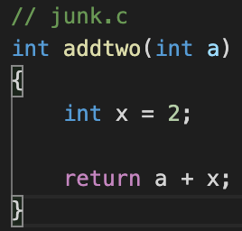

Now to explain that prologue code (all the stuff before .LCFI2:), first:

1. pushl %ebp stores the stack frame of the *calling* function on the stack.
2. movl %esp, %ebp takes the current stack pointer and uses it as the frame for the *called* function.
3. subl $16, %esp leaves room for local variables.

Now your function is ready for business. Any references with a negative offset from the %ebp% register are your local variables (x in this example). Any references with a positive offset from the %ebp% register are your parameters passed in.

